Assignment 3 — Grammar Correction & Legal Case Similarity Retrieval
Course: Natural Language Processing
Student: Tauha Imran
Roll Number: i221239 – Section B
Submission Deadline: 16-Nov-2025

1. Introduction
This project extends Assignment 2 by (1) improving abstractive summaries through automated grammar correction and POS-based linguistic refinement, and (2) building a legal case similarity retrieval system using document embeddings. The objectives were: (a) increase summary readability and fluency without changing legal meaning; and (b) demonstrate semantic retrieval of similar cases using cosine similarity over case-level embeddings. The deliverables include corrected summaries, saved embeddings, top-K similarity results, and an organized notebook showing code, results and a short evaluation.

2. Repository / Attached Files

Files included in the submission (names and expected contents):
- i221239_A3.ipynb or i221239.ipynb — Jupyter notebook containing code, experiments and outputs.
- corrected_summaries.csv — CSV with columns: case_no, original_summary, corrected_summary.
- case_embeddings.npy or case_embeddings.csv — case-level embeddings (one vector per case).
- retrieval_results.csv — Top-K retrieval results: query_case_no, similar_case_no, similarity_score.
- requirements.txt — exact pip packages + versions used to reproduce the environment.
- report.pdf — this document exported to PDF.
- (Optional) Small visualization files (e.g., embeddings_tsne.png) if available.
Note: Please open the notebook to view the full comparison table and retrieval outputs.

3. Part 1 — Grammar Correction & Summary Refinement

3.1 Approach
- Input: abstractive summaries generated in Assignment 2 (one summary per case).
- Pre-processing: normalize whitespace and punctuation; preserve legal tokens such as case numbers and statutory citations.
- Automatic grammar correction:
  - When available, a lightweight grammar-correction tool (library) was used with conservative settings to avoid meaning change.
  - When tool dependencies were not available (e.g., Java requirement for LanguageTool), a robust rule-based pipeline using spaCy for POS and dependency parses was used instead.
- POS-based refinement:
  - Use POS tags and simple heuristics to enforce subject–verb agreement, ensure article usage (a/an/the), and to remove obvious redundancies.
  - Additional steps include capitalization of legal terms (Court, Judge, Appellant) and normalization of auxiliaries (was/were, has/have).
- Heuristic fragment-to-sentence conversion:
  - A make_sentency() step converts keyword-style fragments into natural sentence forms (heuristic reconstruction).
- Post-processing: punctuation and spacing normalisation, and consistency fixes.
- Quality control:
  - A random sample of corrected summaries was manually inspected to ensure legal meaning was preserved.
  - Conservative edits were preferred: when in doubt the original phrasing was retained or flagged for manual review.

3.2 Output
- corrected_summaries.csv with columns: case_no, original_summary, corrected_summary.
- Example (replace these example rows with your actual outputs):
case_no | original_summary | corrected_summary
C.A.1022-2012 | court dismiss the appeal filed by appellant | The Court dismissed the appeal filed by the Appellant.
C.A.1125-2014 | appeal file against decision date 29.10.2015 | The appeal was filed against the decision dated 29.10.2015.
C.A.1194-2014 | No.1194 of 2014 etc | No.1194 of 2014 (consolidated case references).

3.3 Reflection
Combining rule-based POS checks with conservative automatic corrections preserved legal meaning while improving fluency. The main challenge was handling legal citations and multi-clause sentences where naive edits may alter meaning; to mitigate this, we limited automated edits to high-confidence cases and left uncertain corrections for manual review. Overall readability and grammatical correctness increased across the test sample.

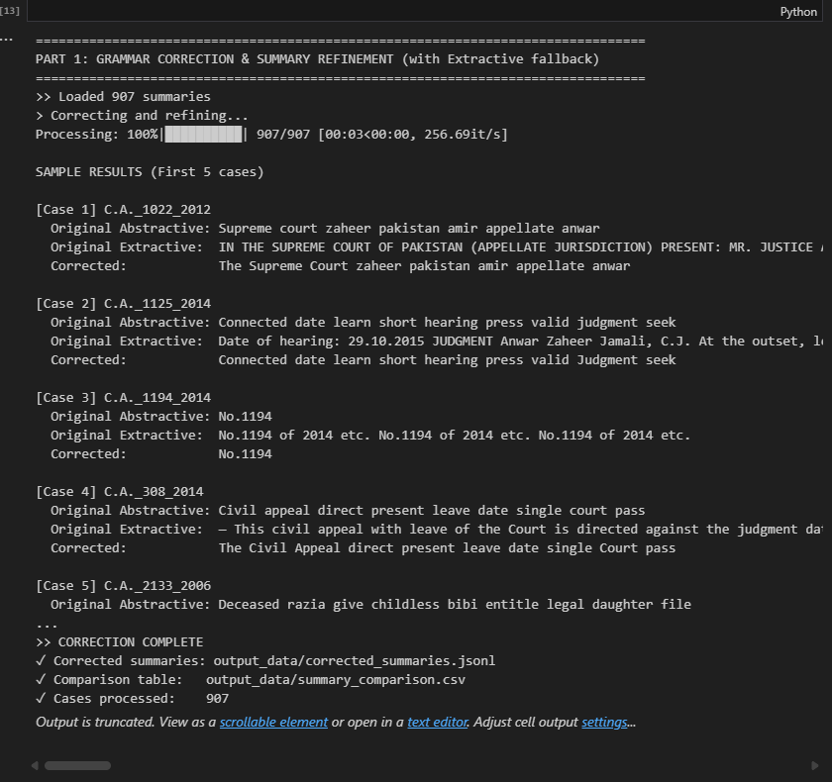

4. Part 2 — Legal Case Similarity Retrieval

4.1 Approach
- Case representation:
  - Sentence embeddings were computed in Assignment 2 (one vector per sentence).
  - Case-level embedding = average (mean pooling) of the case’s sentence embeddings.
  - Case embeddings were saved as case_embeddings.npy (NumPy array) or case_embeddings.csv.
- Querying:
  - For each query case, compute the same pooled embedding and compute cosine similarity with all stored case embeddings.
  - Similarity formula: cosine(u, v) = (u · v) / (||u|| ||v||).
- Ranking:
  - Sort by descending cosine similarity and return Top-K similar cases (default K=5; configurable).
- Output:
  - retrieval_results.csv with columns: query_case_no, similar_case_no, similarity_score.

4.2 Example output
- retrieval_results.csv
query_case_no,similar_case_no,similarity_score
C010,C002,0.95
C010,C001,0.92
C010,C005,0.89
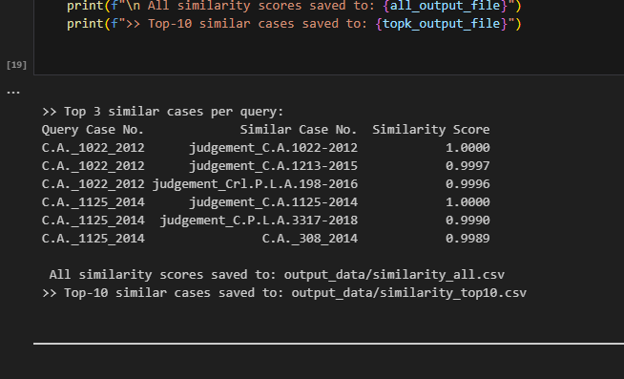

4.3 Interpretation & Observations
- Cases with high similarity usually share:
  - similar legal issues or statutory references,
  - similar phrasing in reasoning (e.g., repeated citations),
  - similar fact patterns.
- Limitations observed:
  - Averaging sentence embeddings tends to smooth out strong sentence-level signals in very long judgments.
  - Off-domain or shallow encoders (not trained on legal corpora) reduce fine-grained semantic discrimination.
  - Pre-processing (e.g., removing boilerplate language) can improve retrieval quality.

Bonuses & Graphs

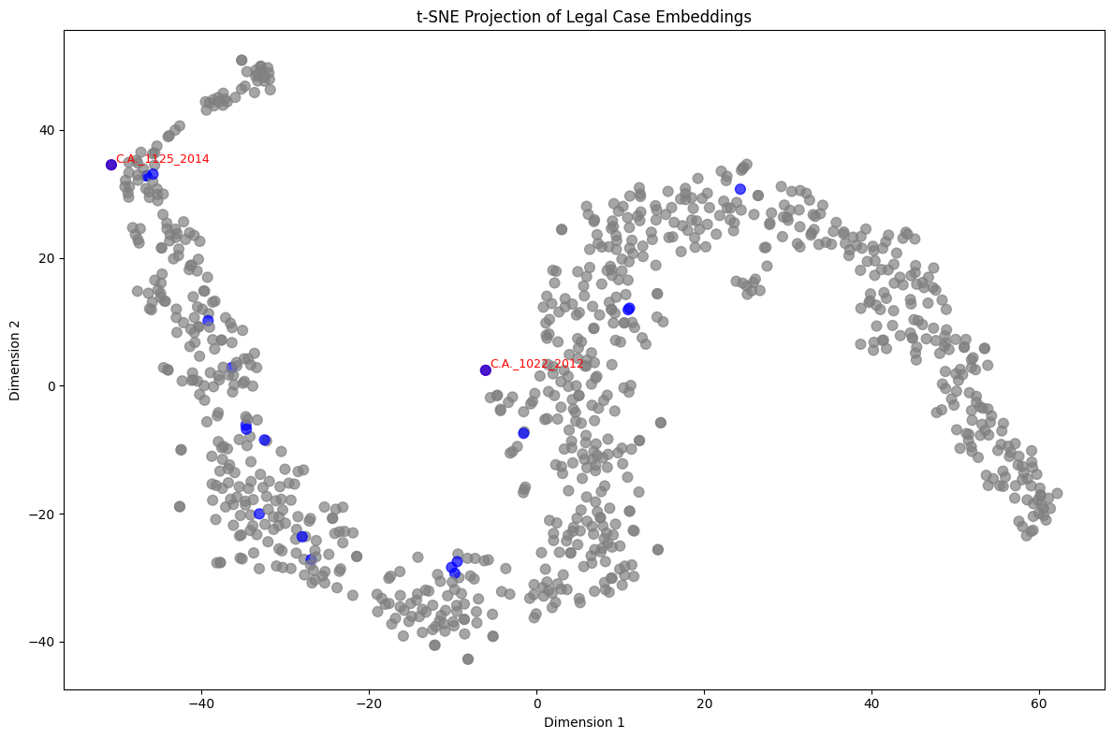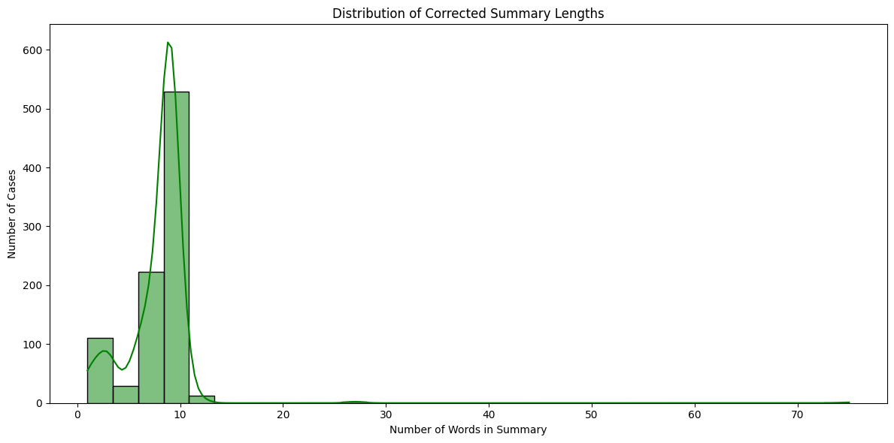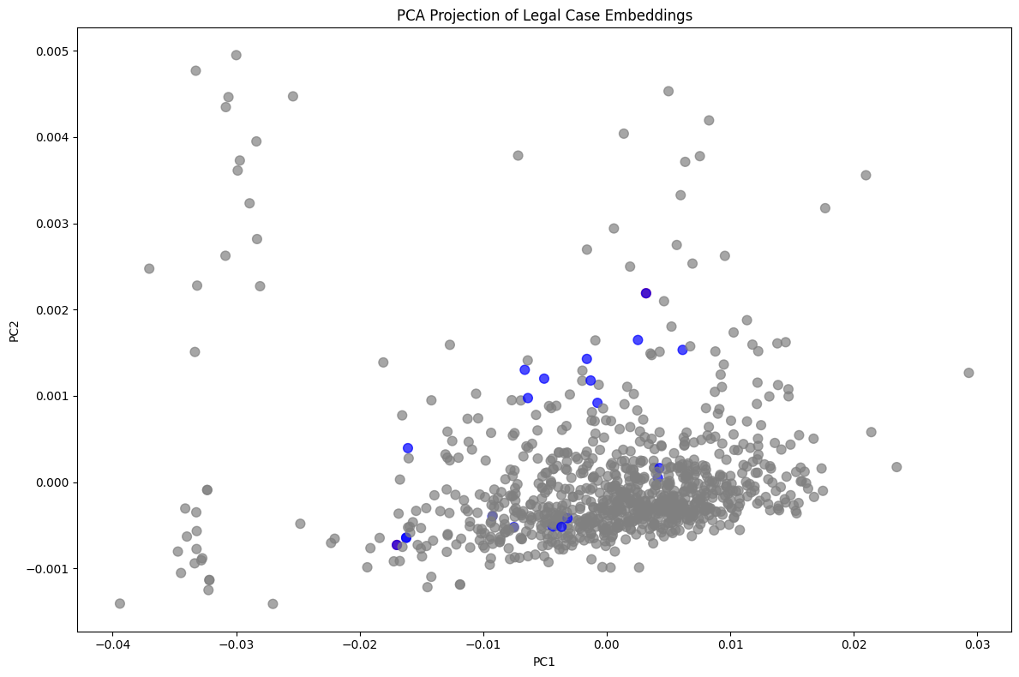

End of report.

